COLLEGE OF ENGINEERING
IITT ALUMNI ASSOCIATION FORM
Student’s Name:
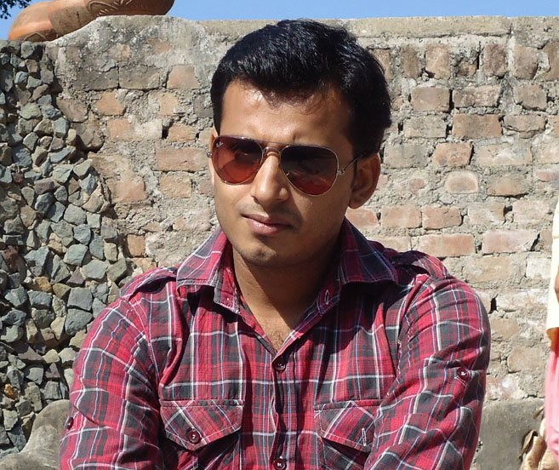e a passport size photograph.
Mohd kashif warsi
Father’s Name:
Mr.Arshad jamal warsi
Your Roll No.:
2054
Branch at IITT:
ECE
Year of passing:
2011
Date of Birth:
16-feb-1987
Sex:
Male
IITT Campus (Kala-Amb or Pojewal):
Kala-Amb
Permanent Address:
Dhramshala road,beside petrol pump,Golghar
Working Experience:
1 year
Contact no. :
9816957198
E-mail ID:
kashifwrs@gmail.com
---------------------------------------------------------------------------------------

